//1.DDA Line – dda.c

#include <stdio.h>
#include <math.h>

#define W 300
#define H 300
static int img[H][W][3] = {0};

void plot(int x, int y, int r, int g, int b) {
if(x>=0 && x<W && y>=0 && y<H){
img[y][x][0] = r;
img[y][x][1] = g;
img[y][x][2] = b;
}
}

void saveImage(char *fname) {
FILE *f = fopen(fname, "w");
fprintf(f,"P3\n%d %d\n255\n", W, H);
for(int y=0;y<H;y++){
for(int x=0;x<W;x++)
fprintf(f,"%d %d %d ", img[y][x][0], img[y][x][1], img[y][x][2]);
fprintf(f,"\n");
}
fclose(f);
}

int main() {
float x1, y1, x2, y2;
printf("Enter x1 y1 x2 y2 : ");
scanf("%f %f %f %f", &x1, &y1, &x2, &y2);

float dx = x2 - x1;
float dy = y2 - y1;
float steps = fabs(dx) > fabs(dy) ? fabs(dx) : fabs(dy);

float xi = dx / steps;
float yi = dy / steps;

float x = x1, y = y1;

for(int i=0;i<=steps;i++){
plot((int)(x+0.5), (int)(y+0.5), 255, 0, 0);
x += xi;
y += yi;
}

saveImage("dda.ppm");
return 0;
}

Output

Enter x1 y1 x2 y2 : 10 20 30 40
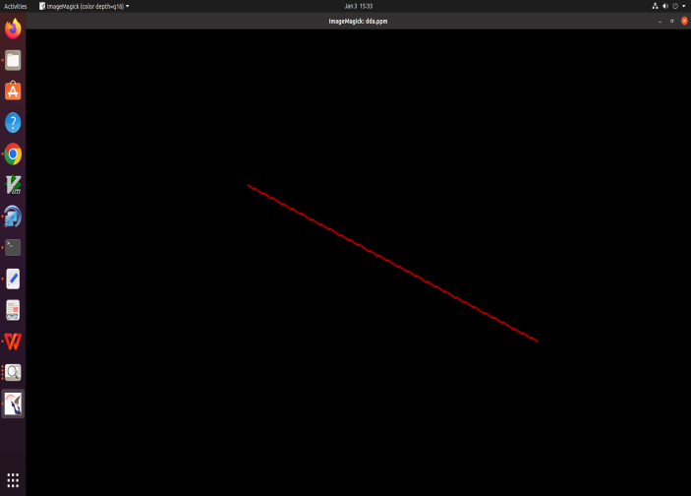

// 2.Bresenham Line – bres_line.c
#include <stdio.h>
#include <stdlib.h>
#define W 300
#define H 300

static int img[H][W][3] = {0};

void plot(int x, int y, int r, int g, int b){
if(x>=0 && x<W && y>=0 && y<H){
img[y][x][0] = r;
img[y][x][1] = g;
img[y][x][2] = b;
}
}

void saveImage(char *fname){
FILE *f = fopen(fname, "w");
fprintf(f, "P3\n%d %d\n255\n", W, H);
for(int y=0;y<H;y++){
for(int x=0;x<W;x++)
fprintf(f,"%d %d %d ", img[y][x][0], img[y][x][1], img[y][x][2]);
fprintf(f,"\n");
}
fclose(f);
}

int main(){
int x1,y1,x2,y2;
printf("Enter x1 y1 x2 y2 : ");
scanf("%d%d%d%d",&x1,&y1,&x2,&y2);

int dx=abs(x2-x1), sx=x1<x2?1:-1;
int dy=-abs(y2-y1), sy=y1<y2?1:-1;
int err = dx + dy, e2;

while(1){
plot(x1,y1,255,255,0);
if(x1==x2 && y1==y2) break;

e2 = 2*err;
if(e2 >= dy){ err += dy; x1 += sx; }
if(e2 <= dx){ err += dx; y1 += sy; }
}

saveImage("bres_line.ppm");
return 0;
}

Output

Enter x1 y1 x2 y2 : 100 200 300 400
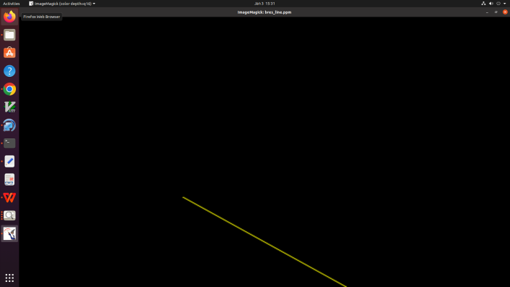

// 3.Bresenham Circle – bres_circle.c
#include <stdio.h>
#define W 500
#define H 500
static int img[H][W][3] = {0};

void plot(int x, int y, int r, int g, int b){
if(x>=0 && x<W && y>=0 && y<H){
img[y][x][0] = r;
img[y][x][1] = g;
img[y][x][2] = b;
}
}

void saveImage(char *fname){
FILE *f = fopen(fname, "w");
fprintf(f,"P3\n%d %d\n255\n",W,H);
for(int y=0;y<H;y++){
for(int x=0;x<W;x++)
fprintf(f,"%d %d %d ",img[y][x][0],img[y][x][1],img[y][x][2]);
fprintf(f,"\n");
}
fclose(f);
}

int main(){
int xc,yc,r;
printf("Enter xc yc r : ");
scanf("%d%d%d",&xc,&yc,&r);

int x=0,y=r;
int d = 3 - 2*r;

while(x <= y){
plot(xc+x,yc+y,255,255,255);
plot(xc-x,yc+y,255,255,255);
plot(xc+x,yc-y,255,255,255);
plot(xc-x,yc-y,255,255,255);
plot(xc+y,yc+x,255,255,255);
plot(xc-y,yc+x,255,255,255);
plot(xc+y,yc-x,255,255,255);
plot(xc-y,yc-x,255,255,255);

if(d < 0)
d += 4*x + 6;
else{
d += 4*(x - y) + 10;
y--;
}
x++;
}

saveImage("bres_circle.ppm");
return 0;
}

Output
Enter xc yc r : 100 150 50
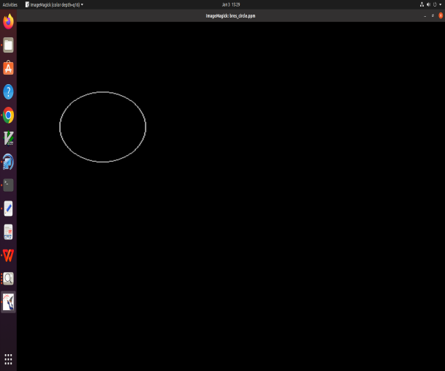

//4. Boundary Fill Algorithm
#include <stdio.h>
#define W 300
#define H 300
static int img[H][W][3] = {0};

void plot(int x, int y, int r, int g, int b){
if(x>=0 && x<W && y>=0 && y<H){
img[y][x][0] = r;
img[y][x][1] = g;
img[y][x][2] = b;
}
}
void saveImage(char *fname){
FILE *f = fopen(fname,"w");
fprintf(f,"P3\n%d %d\n255\n",W,H);
for(int y=0;y<H;y++){
for(int x=0;x<W;x++)
fprintf(f,"%d %d %d ",img[y][x][0],img[y][x][1],img[y][x][2]);
fprintf(f,"\n");
}
fclose(f);
}

void boundaryFill(int x,int y,int fr,int fg,int fb,int br,int bg,int bb){
int *p = img[y][x];
if(p[0]==br && p[1]==bg && p[2]==bb) return;
if(p[0]==fr && p[1]==fg && p[2]==fb) return;

plot(x,y,fr,fg,fb);

boundaryFill(x+1,y,fr,fg,fb,br,bg,bb);
boundaryFill(x-1,y,fr,fg,fb,br,bg,bb);
boundaryFill(x,y+1,fr,fg,fb,br,bg,bb);
boundaryFill(x,y-1,fr,fg,fb,br,bg,bb);
}

int main(){
for(int i=50;i<=250;i++){
plot(i,50,255,0,0);
plot(i,250,255,0,0);
plot(50,i,255,0,0);
plot(250,i,255,0,0);
}

boundaryFill(100,100,0,255,0,255,0,0);
saveImage("boundary.ppm");
return 0;
}

Output

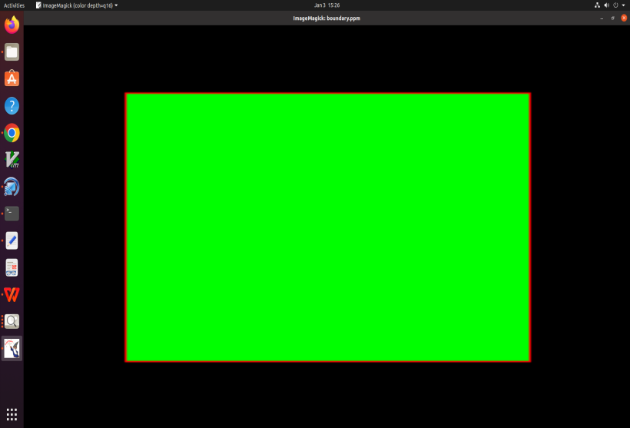

//5.Flood FIll Algorithm
#include <stdio.h>

#define W 300
#define H 300
static int img[H][W][3] = {0};

void plot(int x, int y, int r, int g, int b){
if(x>=0 && x<W && y>=0 && y<H){
img[y][x][0]=r;
img[y][x][1]=g;
img[y][x][2]=b;
}
}

void saveImage(char *fname){
FILE *f = fopen(fname,"w");
fprintf(f,"P3\n%d %d\n255\n",W,H);
for(int y=0;y<H;y++){
for(int x=0;x<W;x++)
fprintf(f,"%d %d %d ",img[y][x][0],img[y][x][1],img[y][x][2]);
fprintf(f,"\n");
}
fclose(f);
}

void floodFill(int x,int y,int tr,int tg,int tb,int fr,int fg,int fb){
int *p = img[y][x];
if(p[0]!=tr || p[1]!=tg || p[2]!=tb) return;

plot(x,y,fr,fg,fb);

floodFill(x+1,y,tr,tg,tb,fr,fg,fb);
floodFill(x-1,y,tr,tg,tb,fr,fg,fb);
floodFill(x,y+1,tr,tg,tb,fr,fg,fb);
floodFill(x,y-1,tr,tg,tb,fr,fg,fb);
}

int main(){
for(int i=80;i<220;i++)
for(int j=80;j<220;j++)
plot(i,j,255,255,255);

floodFill(100,100,255,255,255,0,0,255);
saveImage("flood.ppm");
return 0;
}

Output
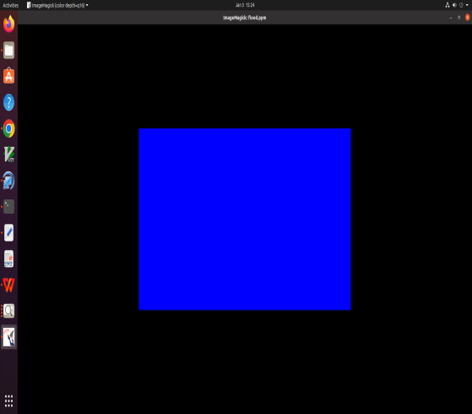

//6.Translation of a triangle
#include <stdio.h>
#include <math.h>
#include <stdlib.h>
#define W 300
#define H 300

static int img[H][W][3] = {0};

void plot(int x, int y, int r, int g, int b){
if(x>=0 && x<W && y>=0 && y<H){
img[y][x][0] = r;
img[y][x][1] = g;
img[y][x][2] = b;
}
}

/* DDA Line Drawing */
void drawLine(int x1, int y1, int x2, int y2){
int dx = x2 - x1;
int dy = y2 - y1;

int steps = abs(dx) > abs(dy) ? abs(dx) : abs(dy);

float xinc = dx / (float)steps;
float yinc = dy / (float)steps;

float x = x1;
float y = y1;

for(int i=0; i<=steps; i++){
plot((int)(x+0.5), (int)(y+0.5), 255,255,255);
x += xinc;
y += yinc;
}
}

void saveImage(char *fname){
FILE *f = fopen(fname,"w");
fprintf(f,"P3\n%d %d\n255\n",W,H);
for(int y=0;y<H;y++){
for(int x=0;x<W;x++)
fprintf(f,"%d %d %d ",
img[y][x][0],
img[y][x][1],
img[y][x][2]);
fprintf(f,"\n");
}
fclose(f);
}
int main(){
int x1=50,y1=50, x2=150,y2=50, x3=100,y3=150;
int tx, ty;

/* Original triangle */
drawLine(x1,y1, x2,y2);
drawLine(x2,y2, x3,y3);
drawLine(x3,y3, x1,y1);

printf("Enter translation tx ty : ");
scanf("%d %d",&tx,&ty);

/* Translated triangle */
drawLine(x1+tx, y1+ty, x2+tx, y2+ty);
drawLine(x2+tx, y2+ty, x3+tx, y3+ty);
drawLine(x3+tx, y3+ty, x1+tx, y1+ty);

saveImage("tri.ppm");
return 0;
}

Output
Enter translation tx ty : 100 150

